Inflation from previous week
Is inflation bad
- Inflation expectations can erode the value of savings
- Inflation expectations can bring forward consumption, causing hyperinflation
- Higher inflation increases the demand for money (Fischer equation) vs money in the bank. Fischer equation – nominal IR equals real IR plus inflation (expectations)
- Because people consider inflation expectations, it is important to have stability in monetary policy and announce it
- Neutrality of money in LR
- Inflation only reduces real wages in the short run when nominal wages e fixed by contracts. In the long run all prices can adjust – wage is determined by labour supply and MRP, not price level or inflation rate
- In our models, all factors are paid their marginal products.

- Classical view of inflation is that prices don’t matter because in the long run prices cannot affect real economic activity e.g. unemployment, GDP, consumption, investment. Neutrality of money is that inflation has no real effects –

Cost of expectation
- Shoe leather costs – inconveniences of reducing money balances to avoid the “inflation tax”. Nominal interest rate goes up, so does cost of holding money. Put money in the bank to avoid inflation cost.
  - Cash dependant economies have higher shoe leather costs (emerging economies)
  - Internet banking reduce transaction costs
- Menu costs of expected inflation – the cost of changing prices e.g. printing and mailing new catalogues and menus. The higher inflation is, the more frequently firms must change their prices and incur these costs.
- Relative price distortions – different firms change their prices at different times, leading to price distortions relative to the general price level. This creates microeconomic inefficiencies in how consumers allocate their income to consumption
- Unfair tax treatment – some taxes are not adjusted to account for inflation.

- Money multiplier changes in levels of crisis. Money supply growth has been huge post 2008 but inflation has been super low

- Hyperinflation caused by excessive money supply growth so in theory the solution is just to stop printing money.

- Fiscal causes of high inflation – the government budget constraint. G = T + change in borrowing + changes in the stock of money

- Inflation taxes people holding cash. If you’re holding other assets, their value goes up.

- If government runs large budget deficits, as debt rises lenders may stop lending to the government.
  - Debt solution could be raising taxes – may not be politically feasible
  - So government’s may resort to printing currency to financing its budget
  - It requires drastic and painful fiscal restraint to stop hyperinflation

- Reaction to short run shocks can affect long run potential
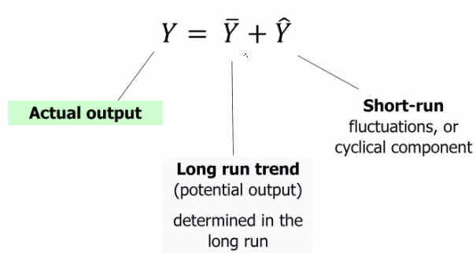
- Y bar is given in solow – we want to understand Y hat, the deviation from potential
- Referred to as detrended output or short-run output
- Business cycle

Meausring potential ouput
- Recession = 2 consecutive quarters of negative GDP growth
- Could take years to reach same standard of living after covid
Business cycle theory
- Economy is constantly hit by shocks. Propagation mechanism leads to fluctuations in real GDP.
- SRAS is a function of prices. LRAS is dependant on FoPs and not price levels or finlation
- SRAS affects the price level. Price level affects AD
Basic facts – more or less severe based on each economy’s structure.
- Consumption much more stable wrt GDP than investment is. Rolling consumption (consumption smoothing for constant living standard). Autonomous consumption as a base level. Savings must fall, falling supply of loanable funds. Companies cut back on projects to maintain cash buffers.
- Okun’s law.
  - Unem
- In recessions we have disinflation and maybe deflation as firms compete for falling demand, workers are laid off and so demand falls further

Index of leading economic indicators
- Changes in investment affect the steady state and long run growth
- To prevent short run cycles we need indicators to show us whether we are in a boom or bust. Forecasting is important because the state of the economy affects government budgeting, informs investment decisions, informs government monetary and fiscal policy
Components of the LEI are those which change fast
- Average workweek in manufacturing – shows demand for products before the time taken to fire or hire labour
- Initial weekly claims or unemployment insurance
- New orders for consumer goods and materials
- Vendor performance
- New building permits issued – long term investment which indicate firms’ view about economic activity in the near future
- Index of stock prices
- M2
- Yield spreads – difference between short and long term bonds. Big yield spread means people expect interest rates to be higher in the future because a boom is coming. So shows investors have a positive view of the economy
Time horizons
Long run – prices are flexible to changes in supply and demand
Short run – prices are sticky at a pre-determined level

